Chapter 18
The Markets for the Factors of Production
Multiple Choice
1. Which of the following best describes the economy’s stock of equipment and structures?
a. capital
b. aggregate demand
c. long-term inventory
d. aggregate stock
ANSWER: a. capital
TYPE: M DIFFICULTY: 1 SECTION: 18.1
2. Rent, interest, and profit are all forms of income paid to the owners of
a. aggregate stock.
b. aggregate demand.
c. firms and non-for-profit organizations.
d. land and capital.
ANSWER: d. land and capital.
TYPE: M DIFFICULTY: 1 SECTION: 18.1
3. The factors of production are best defined as the
a. output produced from raw materials.
b. inputs used to produce goods and services.
c. wages paid to the workforce.
d. goods and services sold in the market.
ANSWER: b. inputs used to produce goods and services.
TYPE: M DIFFICULTY: 1 SECTION: 18.1
4. For a computer software firm, capital could be thought of as
(i) the firm’s computer programmers.
(ii) the wages the firm pays to its computer programmers.
(iii) computer equipment.
a. (i) only
b. (ii) only
c. (iii) only
d. (i) and (iii)
ANSWER: c. (iii) only
TYPE: M DIFFICULTY: 1 SECTION: 18.1
5. For a retail gasoline station, which of the following would qualify as capital?
(i) the gas tanks and pumps
(ii) the service attendants’ time
(iii) the plot of land on which the station sits
a. (i) only
b. (iii) only
c. (i) and (iii)
d. (ii) and (iii)
ANSWER: a. (i) only
TYPE: M DIFFICULTY: 1 SECTION: 18.1
6. Because a firm’s demand for a factor of production is derived from its decision to supply a good in the market, we call this type of demand
a. differentiated demand.
b. secondary demand.
c. derived demand.
d. hybrid demand-supply.
ANSWER: c. derived demand.
TYPE: M DIFFICULTY: 1 SECTION: 18.1
7. Most of the total income earned in the U.S. economy is ultimately paid to households in the form of
a. profit.
b. rent.
c. interest.
d. wages.
ANSWER: d. wages.
TYPE: M DIFFICULTY: 1 SECTION: 18.1
8. In the United States economy, which of the following factors of production is considered to be the most important in terms of the magnitude of income earned by that factor of production?
a. land
b. labor
c. profit
d. capital
ANSWER: b. labor
TYPE: M DIFFICULTY: 1 SECTION: 18.1
9. The basic tools of supply and demand apply to
a. markets for goods and services and to markets for labor services.
b. markets for goods and services but not to markets for labor services.
c. markets for goods and services but not to markets for factors of production.
d. all markets except those in which demand is a derived demand.
ANSWER: a. markets for goods and services and to markets for labor services.
TYPE: M DIFFICULTY: 2 SECTION: 18.1
10. Labor markets are different from most other markets because labor demand is
a. represented by a vertical line on a supply-demand diagram.
b. represented by an upward-sloping line on a supply-demand diagram.
c. such an elusive concept.
d. derived.
ANSWER: d. derived.
TYPE: M DIFFICULTY: 1 SECTION: 18.1
11. Which of the following best illustrates the concept of “derived demand?”
a. An increase in the wages of autoworkers will lead to an increase in the demand for robots in automobile factories.
b. An automobile producer's decision to supply more cars will lead to an increase in the demand for automobile production workers.
c. An automobile producer's decision to supply more minivans results from a decrease in the demand for station wagons.
d. An increase in the price of gasoline will lead to an increase in the demand for small cars.
ANSWER: b. An automobile producer's decision to supply more cars will lead to an increase in the demand for automobile production workers.
TYPE: M DIFFICULTY: 2 SECTION: 18.1
12. The term “factor market“ applies to the market for
a. labor.
b. capital.
c. land.
d. All of the above are correct.
ANSWER: d. All of the above are correct.
TYPE: M DIFFICULTY: 1 SECTION: 18.1
13. Factor markets are different from product markets in an important way, because
a. equilibrium is the exception, and not the rule, in factor markets.
b. the demand for a factor of production is a derived demand.
c. the demand for a factor of production is likely to be upward sloping, in violation of the law of demand.
d. All of the above are correct.
ANSWER: b. the demand for a factor of production is a derived demand.
TYPE: M DIFFICULTY: 2 SECTION: 18.1
14. How much of the income in the United States is in the form of wages and fringe benefits?
a. more than 90 percent
b. about 75 percent
c. about 50 percent
d. less than 75 percent
ANSWER: b. about 75 percent
TYPE: M DIFFICULTY: 1 SECTION: 18.1
15. Factor market analysis could not be complete without some characterization of
a. product-market demand.
b. the marginal productivities of the different factors.
c. market prices for final goods and services.
d. All of the above are correct.
ANSWER: d. All of the above are correct.
TYPE: M DIFFICULTY: 2 SECTION: 18.1

Use the following information to answer questions 16 through 22.

Gertrude Kelp owns three boats, which participate in commercial fishing for fresh Pacific salmon off the coast of Alaska. As part of her business she hires a captain and several crewmembers for each boat. In the market for fresh Pacific salmon, there are thousands of firms like Gertrude’s. While Gertrude usually catches a significant number of fish each year, her contribution to the entire harvest of salmon is negligible relative to the size of the market.
16. Based on the given information, it is likely that Gertrude’s firm has
a. some influence over the wages paid to crewmembers, but no influence over the price of salmon.
b. some influence over the price of salmon, but no influence over the wages paid to crewmembers.
c. some influence over both the price of salmon and over the wages paid to crewmembers.
d. no influence over either the price of salmon or over the wages paid to crewmembers.
ANSWER: d. no influence over either the price of salmon or over the wages paid to crewmembers.
TYPE: M DIFFICULTY: 2 SECTION: 18.1
17. When Gertrude participates in the labor market to hire crewmembers for her boats, she is most likely considered a
a. demander of labor services.
b. supplier of labor services.
c. buyer of capital.
d. demander of capital.
ANSWER: a. demander of labor services.
TYPE: M DIFFICULTY: 1 SECTION: 18.1
18. If the price of fresh Pacific salmon were to decrease significantly, it is most likely that Gertrude would
a. reduce her demand for crewmembers.
b. try to increase her catch to make up for lost revenue.
c. become a seller in at least one factor market.
d. hire more crewmembers.
ANSWER: a. reduce her demand for crewmembers.
TYPE: M DIFFICULTY: 2 SECTION: 18.1
19. If Gertrude is a competitor in both the fresh Pacific salmon market and in the market for crewmembers she is called a price
a. taker in the salmon market and a wage setter in the crew market.
b. taker in the crew market and a price setter in the salmon market.
c. taker in both markets.
d. setter in both markets.
ANSWER: c. taker in both markets.
TYPE: M DIFFICULTY: 2 SECTION: 18.1
20. In the fresh Pacific salmon product market Gertrude has control over
a. the price she charges for her fresh salmon.
b. the quantity of fresh salmon that she catches and supplies to the market.
c. the competitive environment of the market.
d. All of the above are correct.
ANSWER: b. the quantity of fresh salmon that she catches and supplies to the market.
TYPE: M DIFFICULTY: 1 SECTION: 18.1
21. If Gertrude is a price taker in the labor market, she decides
a. the price for which she will sell the fish she catches.
b. how many crewmembers she will hire.
c. the wages that she will pay to her crewmembers.
d. All of the above are correct.
ANSWER: b. how many crewmembers she will hire.
TYPE: M DIFFICULTY: 1 SECTION: 18.1
22. Labor market theory assumes that Gertrude's demand for crewmembers and her supply of fresh Pacific salmon results from her
a. intrinsic desire to hire crewmembers.
b. primary goal of maximizing profit.
c. altruistic motives to provide fresh salmon to consumers.
d. desire to strike a balance between environmental concerns and maximum profit.
ANSWER: b. primary goal of maximizing profit.
TYPE: M DIFFICULTY: 1 SECTION: 18.1
23. When a firm is a profit maximizer
a. it is driven to produce as much of its product as possible.
b. it will measure its success by the number of employees it has.
c. its revenue will always be maximized as well.
d. it does not care directly about the number of workers it hires.
ANSWER: d. it does not care directly about the number of workers it hires.
TYPE: M DIFFICULTY: 2 SECTION: 18.1
24. Along the horizontal axis of the production function we typically measure
a. revenue.
b. the marginal product of the input.
c. the quantity of input.
d. the quantity of output.
ANSWER: c. the quantity of input.
TYPE: M DIFFICULTY: 1 SECTION: 18.1
25. The marginal product of labor is defined as the change in
a. output per additional unit of revenue.
b. output per additional unit of labor.
c. revenue per additional unit of labor.
d. revenue per additional unit of output.
ANSWER: b. output per additional unit of labor.
TYPE: M DIFFICULTY: 1 SECTION: 18.1
26. If hiring more workers results in each additional worker contributing successively smaller amounts of output, then
a. diminishing profitability is present.
b. diminishing marginal cost is present.
c. diminishing marginal product is present.
d. increasing marginal product is present.
ANSWER: c. diminishing marginal product is present.
TYPE: M DIFFICULTY: 1 SECTION: 18.1
27. Diminishing marginal product serves to have what effect on the shape of the production function?
a. The slope of the production function decreases as the quantity of input increases.
b. The production function becomes steeper as the quantity of input increases.
c. The production function slopes downward.
d. The production function is horizontal beyond a certain quantity of input.
ANSWER: a. The slope of the production function decreases as the quantity of input increases.
TYPE: M DIFFICULTY: 2 SECTION: 18.1
28. When deciding whether to hire an additional worker, firms look at how the additional worker would affect
a. costs only.
b. revenue only.
c. output only.
d. profit.
ANSWER: d. profit.
TYPE: M DIFFICULTY: 2 SECTION: 18.1
29. The contribution to profit from an additional worker can be measured by the change in
a. profit B marginal product.
b. cost B wage.
c. revenue B wage.
d. profit B wage.
ANSWER: c. revenue B wage.
TYPE: M DIFFICULTY: 2 SECTION: 18.1
30. The value of the marginal product of any input is equal to the marginal product of that input multiplied by the
a. additional revenue.
b. marginal cost of the output.
c. change in total profit.
d. market price of the output.
ANSWER: d. market price of the output.
TYPE: M DIFFICULTY: 2 SECTION: 18.1
31. The value of the marginal product of labor is equal to the change in
a. marginal cost caused by the addition of the last worker.
b. total cost caused by the addition of the last worker.
c. total revenue caused by the addition of the last worker.
d. total profit caused by the addition of the last worker.
ANSWER: c. total revenue caused by the addition of the last worker.
TYPE: M DIFFICULTY: 2 SECTION: 18.1
32. What is the shape of the curve that represents the value of the marginal product of labor?
a. U-shaped
b. flat
c. downward sloping
d. upward sloping
ANSWER: c. downward sloping
TYPE: M DIFFICULTY: 2 SECTION: 18.1
33. To maximize profit, a competitive firm hires workers up to the point of intersection of the
a. marginal-product curve and the marginal-cost curve.
b. value-of-marginal-product curve and the wage line.
c. value-of-marginal-product curve and the marginal-revenue curve.
d. total-revenue curve and the wage line.
ANSWER: b. value-of-marginal-product curve and the wage line.
TYPE: M DIFFICULTY: 2 SECTION: 18.1
34. The shape of the value-of-marginal-product curve is most easily explained by
a. tight labor markets.
b. a surplus of workers.
c. diminishing marginal product.
d. diminishing marginal cost.
ANSWER: c. diminishing marginal product.
TYPE: M DIFFICULTY: 2 SECTION: 18.1
35. If the value of the marginal product of labor exceeds the wage, then hiring another worker increases the firm’s
a. profit.
b. total cost.
c. total revenue.
d. All of the above are correct.
ANSWER: d. All of the above are correct.
TYPE: M DIFFICULTY: 2 SECTION: 18.1
36. If the wage exceeds the value of the marginal product of labor, then hiring another worker
a. decreases the firm’s total revenue.
b. increases the firm’s profit.
c. increases the firm’s total cost.
d. All of the above are correct.
ANSWER: c. increases the firm’s total cost.
TYPE: M DIFFICULTY: 2 SECTION: 18.1
37. A competitive, profit-maximizing firm hires workers up to the point where the
a. marginal product equals zero.
b. marginal revenue product equals zero.
c. marginal product equals the wage.
d. value of the marginal product equals the wage.
ANSWER: d. value of the marginal product equals the wage.
TYPE: M DIFFICULTY: 2 SECTION: 18.1
38. For a competitive, profit-maximizing firm the labor demand curve is the same as the
a. marginal cost curve.
b. value of marginal product curve.
c. production function.
d. profit function.
ANSWER: b. value of marginal product curve.
TYPE: M DIFFICULTY: 2 SECTION: 18.1
39. When labor is the only input a firm uses, the marginal cost of a unit of output can be defined as
a. marginal revenue B wage.
b. marginal product of labor B wage.
c. wage divided by marginal product of labor.
d. marginal product of labor divided by wage.
ANSWER: c. wage divided by marginal product of labor.
TYPE: M DIFFICULTY: 3 SECTION: 18.1
40. Diminishing marginal product is closely related to
a. diminishing total cost.
b. diminishing marginal cost.
c. diminishing variable cost.
d. increasing marginal cost.
ANSWER: d. increasing marginal cost.
TYPE: M DIFFICULTY: 2 SECTION: 18.1
41. When a production function exhibits a diminishing, but positive, marginal product of labor,
a. profit always increases as output increases.
b. profit always decreases as output increases.
c. output declines as more workers are employed.
d. output increases, but at a decreasing rate, as more workers are employed.
ANSWER: d. output increases, but at a decreasing rate, as more workers are employed.
TYPE: M DIFFICULTY: 2 SECTION: 18.1
42. A worker's contribution to a firm's revenue is measured directly by the worker's
a. marginal product.
b. value of marginal product.
c. marginal product multiplied by his/her wage.
d. value of marginal product multiplied by his/her wage.
ANSWER: b. value of marginal product.
TYPE: M DIFFICULTY: 2 SECTION: 18.1
43. A profit-maximizing competitive firm for which the marginal product of labor is diminishing also experiences
a. a perfectly inelastic supply of labor.
b. a perfectly elastic supply of labor.
c. a downward-sloping demand for labor.
d. an upward-sloping demand for labor.
ANSWER: c. a downward-sloping demand for labor.
TYPE: M DIFFICULTY: 2 SECTION: 18.1
44. If one observes a profit-maximizing firm starting with 50 employees and then increasing employment, it is possible to infer that, when 50 employees are hired, the
a. wage exceeds the value of the marginal product of labor.
b. value of the marginal product or labor exceeds the wage.
c. marginal product of labor is increasing.
d. firm is attempting to increase its market share.
ANSWER: b. value of the marginal product or labor exceeds the wage.
TYPE: M DIFFICULTY: 2 SECTION: 18.1
45. Letting Δ denote change, a competitive firm will hire an additional worker only if the result of hiring that worker is that
a. Δ revenue > Δ cost.
b. Δ revenue > Δ profit.
c. Δ profit > Δ cost.
d. Δ marginal product > Δ cost.
ANSWER: a. Δ revenue > Δ cost.
TYPE: M DIFFICULTY: 2 SECTION: 18.1
46. A profit-maximizing, competitive firm will always hire an additional worker when the additional worker makes a positive contribution to
a. total revenue.
b. total profit.
c. the value of the marginal product of labor.
d. marginal revenue.
ANSWER: b. total profit.
TYPE: M DIFFICULTY: 2 SECTION: 18.1
47. If one observes a profit-maximizing firm starting with 25 employees and then decreasing employment, it is possible to infer that, when 25 employees are hired, the
a. firm is losing market share.
b. firm is not likely to be minimizing losses.
c. wage exceeds the value of the marginal product of labor.
d. value of the marginal product of labor exceeds the wage.
ANSWER: c. wage exceeds the value of the marginal product of labor.
TYPE: M DIFFICULTY: 2 SECTION: 18.1
48. For a competitive firm that finds it worthwhile to operate, rather than shut down, attainment of the usual objective requires that
a. output price = marginal cost.
b. wage = value of marginal product of labor.
c. profit is maximized.
d. All of the above are correct.
ANSWER: d. All of the above are correct.
TYPE: M DIFFICULTY: 2 SECTION: 18.1
49. A competitive firm will hire workers up to the point at which the value of the marginal product of labor equals the
a. average total cost.
b. average variable cost.
c. wage.
d. price per unit of output.
ANSWER: c. wage.
TYPE: M DIFFICULTY: 2 SECTION: 18.1
50. What causes the labor demand curve to shift?
(i) changes in productivity
(ii) changes in wages
(iii) changes in output prices
a. (i) and (ii)
b. (ii) and (iii)
c. (i) and (iii)
d. All of the above are correct.
ANSWER: c. (i) and (iii)
TYPE: M DIFFICULTY: 2 SECTION: 18.1
51. If the price of airline tickets falls, what will happen to the demand curve for flight attendants?
a. It will shift upward.
b. It will shift to the left.
c. It will shift to the right.
d. It will remain unchanged; price changes do not shift demand curves.
ANSWER: b. It will shift to the left.
TYPE: M DIFFICULTY: 2 SECTION: 18.1
52. If consumers demand more genetically engineered foods, the value of genetic engineers’ marginal product of labor will
a. rise.
b. fall.
c. remain unchanged.
d. rise or fall; either is possible.
ANSWER: a. rise.
TYPE: M DIFFICULTY: 2 SECTION: 18.1

Use the following table to answer questions 53 through 61.

Number of Workers | Output | Marginal Product  of Labor | Value of Marginal Product  of Labor | Wage | Marginal Profit
0 | 0
1 | 100 |  | $1,000 | $500 | $500
2 |  | 80 | $800 | $500
3 |  | 60 |  | $500 | $100
4 | 280 |  | $400 | $500
5 |  | 20 |  | $500
53. What is the market price of the final good?
a. $5
b. $6
c. $8
d. $10
ANSWER: d. $10
TYPE: M DIFFICULTY: 2 SECTION: 18.1
54. It is apparent from this table that increasing marginal product
a. occurs only after the first worker is hired.
b. occurs only after the second worker is hired.
c. occurs only after the third worker is hired.
d. never occurs.
ANSWER: d. never occurs.
TYPE: M DIFFICULTY: 2 SECTION: 18.1
55. If the firm hires two workers, the two workers together produce
a. 80 units.
b. 100 units.
c. 180 units.
d. 200 units.
ANSWER: c. 180 units.
TYPE: M DIFFICULTY: 2 SECTION: 18.1
56. What is the marginal product of the fourth worker?
a. 30
b. 40
c. 60
d. 100
ANSWER: b. 40
TYPE: M DIFFICULTY: 2 SECTION: 18.1
57. The fact that the marginal product changes as the number of workers increases exemplifies a property called
a. diminishing marginal product.
b. utility maximization.
c. supply and demand.
d. labor theory.
ANSWER: a. diminishing marginal product.
TYPE: M DIFFICULTY: 1 SECTION: 18.1
58. What is the marginal profit of the fourth worker?
a. $400
b. $200
c. $0
d. $–100
ANSWER: d. $–100
TYPE: M DIFFICULTY: 1 SECTION: 18.1
59. What is the fourth worker’s contribution to total revenue?
a. $–100
b. $200
c. $400
d. $500
ANSWER: c. $400
TYPE: M DIFFICULTY: 2 SECTION: 18.1
60. To maximize its profit, how many workers will the firm hire?
a. 2
b. 3
c. 4
d. 5
ANSWER: b. 3
TYPE: M DIFFICULTY: 2 SECTION: 18.1
61. To maximize its profit, the firm will hire workers as long as the value of the marginal product of labor equals or exceeds
a. $200.
b. $300.
c. $400.
d. $500.
ANSWER: d. $500.
TYPE: M DIFFICULTY: 2 SECTION: 18.1
62. For maximum profit, a firm hires labor up to the point at which the wage equals
(i) the value of the marginal product of labor.
(ii) the marginal cost of an additional unit of output.
(iii) output price × marginal product of labor.
a. (i) and (ii)
b. (i) and (iii)
c. (ii) and (iii)
d. All of the above are correct.
ANSWER: b. (i) and (iii)
TYPE: M DIFFICULTY: 2 SECTION: 18.1
63. Competitive firms that maximize profit will hire workers until the value of the marginal product of labor
a. equals the wage.
b. equals the price of the final good.
c. begins to fall.
d. begins to rise.
ANSWER: a. equals the wage.
TYPE: M DIFFICULTY: 2 SECTION: 18.1
64. For the profit-maximizing competitive firm, the value-of-marginal-product curve is
a. always rising.
b. falling only when marginal product is rising.
c. the labor supply curve.
d. the labor demand curve.
ANSWER: d. the labor demand curve.
TYPE: M DIFFICULTY: 2 SECTION: 18.1

The figure represents the value of marginal product for a firm that sells its product in a competitive market. Use the following figure to answer questions 65 through 68.

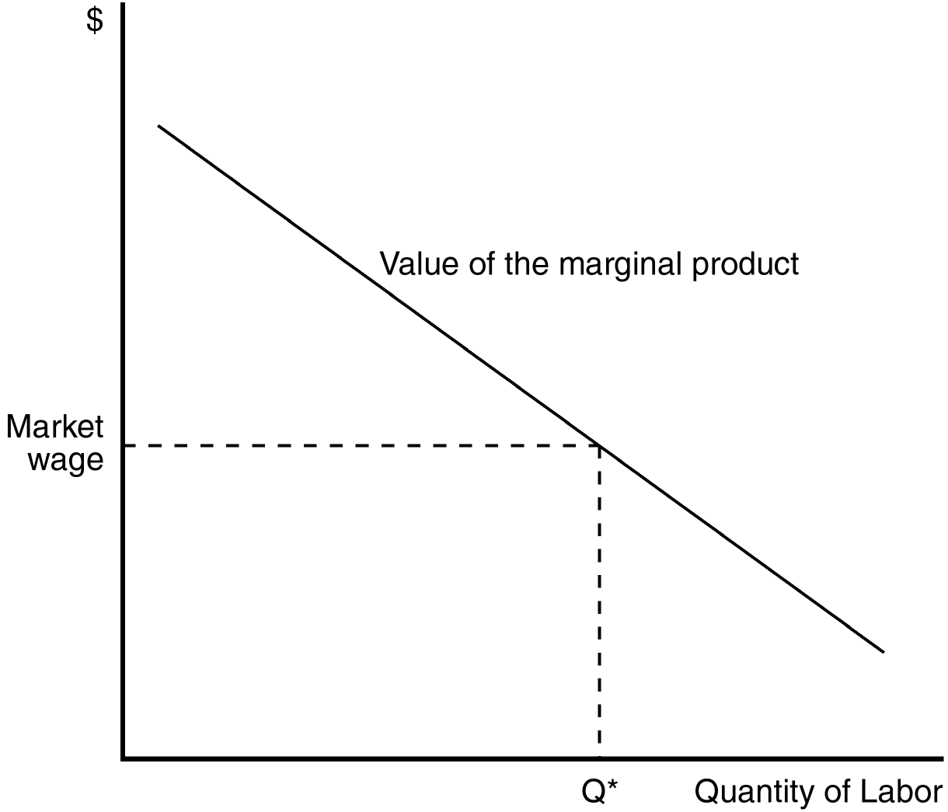

65. The value of the marginal-product curve shown in this figure is the same as which of the following?
a. the labor-supply curve
b. the labor-demand curve
c. the marginal-revenue curve
d. the total-revenue curve
ANSWER: b. the labor-demand curve
TYPE: M DIFFICULTY: 2 SECTION: 18.1
66. The shape of the curve suggests the presence of
a. increased productivity with increased labor.
b. increasing returns to scale.
c. increasing returns to scale.
d. diminishing marginal product.
ANSWER: d. diminishing marginal product.
TYPE: M DIFFICULTY: 2 SECTION: 18.1
67. To maximize profit, a firm will hire a quantity of labor
a. less than Q*.
b. greater than Q*.
c. equal to Q*.
d. that cannot be determined from the diagram. The supply curve is needed to make this determination.
ANSWER: c. equal to Q*.
TYPE: M DIFFICULTY: 1 SECTION: 18.1
68. If a firm were employing fewer than Q* workers, hiring more workers would
a. increase marginal product.
b. decrease the price of the final good.
c. increase profit.
d. decrease profit.
ANSWER: c. increase profit.
TYPE: M DIFFICULTY: 2 SECTION: 18.1
69. For a competitive firm, the value of the marginal product
(i) increases when the price of output decreases.
(ii) changes when marginal product changes.
(iii) diminishes as the number of workers rises.
a. (i) and (ii)
b. (i) and (iii)
c. (ii) and (iii)
d. All of the above are correct.
ANSWER: c. (ii) and (iii)
TYPE: M DIFFICULTY: 2 SECTION: 18.1
70. What does a firm’s labor-demand curve represent?
a. the quantity of labor supplied at the market wage
b. the marginal product of labor
c. the number of workers that are willing to work at any given wage
d. the number of workers that the firm is willing to hire at any given wage
ANSWER: d. the number of workers that the firm is willing to hire at any given wage
TYPE: M DIFFICULTY: 2 SECTION: 18.1
71. Competitive firms decide how much output to sell by producing output until the price of the good equals
a. marginal product.
b. the value of marginal product.
c. marginal cost.
d. marginal profit.
ANSWER: c. marginal cost.
TYPE: M DIFFICULTY: 2 SECTION: 18.1
72. Competitive firms hire workers up to the point at which the additional benefit they receive from the last worker hired is equal to
(i) the additional cost of that worker.
(ii) the wage paid to that worker.
(iii) the price of the good they sell to consumers.
a. (i) only
b. (iii) only
c. (i) and (ii)
d. (ii) and (iii)
ANSWER: c. (i) and (ii)
TYPE: M DIFFICULTY: 2 SECTION: 18.1
73. Dan owns one of the many bakeries in New York City. Which of the following events will lead to an increase in Dan’s demand for the services of bakers?
(i) The price of muffins increases. (Muffins are Dan’s specialty.)
(ii) Dan adds three new ovens to the kitchen area to help the bakers work faster.
(iii) Local bakers form a union to protect themselves from low wages.
a. (i) and (ii)
b. (ii) and (iii)
c. (i) and (iii)
d. All of the above are correct.
ANSWER: a. (i) and (ii)
TYPE: M DIFFICULTY: 2 SECTION: 18.1
74. Charles owns one of many bakeries in New York City. Which of the following events will lead to a decrease in Charles’s demand for the services of bakers?
a. Hollywood glamorization of a new movie about a baker leads hundreds of high-school students in New York City to apply for a job at Dan’s.
b. The price of baked goods falls.
c. The local bakers form a union.
d. All of the above are correct.
ANSWER: b. The price of baked goods falls.
TYPE: M DIFFICULTY: 2 SECTION: 18.1
75. Economists refer to the inputs that firms use to produce goods and services as
a. derived factors.
b. derived resources.
c. factors of production.
d. instruments of revenue.
ANSWER: c. factors of production.
TYPE: M DIFFICULTY: 1 SECTION: 18.1
76. Given that wheat is an important ingredient in bread, which of the following statements is correct?
a. The supply of wheat is derived from consumers’ choices, which determine the demand for bread.
b. The demand for wheat is derived from firms’ choices, which determine the supply of bread.
c. The demand for wheat and the demand for bread are both derived demands.
d. Neither the demand for wheat nor the demand for bread is a derived demand.
ANSWER: b. The demand for wheat is derived from firms’ choices which determine the supply of bread.
TYPE: M DIFFICULTY: 2 SECTION: 18.1
77. A sandwich shop hires workers to make sandwiches and sell them to customers. If the firm is competitive in both the market for sandwiches and in the market for sandwich-makers, then it has
a. some control over both the price of sandwiches and the wage it pays to its workers.
b. no control over the price of sandwiches but it has some control over the wage it pays to its workers.
c. some control over the price of sandwiches but it has no control over the wage it pays to its workers.
d. no control over either the price of sandwiches or the wage it pays to its workers.
ANSWER: d. no control over either the price of sandwiches or the wage it pays to its workers.
TYPE: M DIFFICULTY: 1 SECTION: 18.1
78. When we focus on the firm as a supplier of a good or a service, we assume that the firm is a profit maximizer. When we focus on the firm as a demander of labor, we assume that the firm’s objective is to
a. minimize wages.
b. minimize variable costs.
c. maximize the number of workers hired.
d. maximize profit.
ANSWER: d. maximize profit.
TYPE: M DIFFICULTY: 1 SECTION: 18.1
79. The value of the marginal product of labor is calculated by multiplying the
a. price of output by the quantity of labor.
b. price of output by the marginal product of labor.
c. wage by the quantity of labor.
d. wage by the marginal product of labor.
ANSWER: b. price of output by the marginal product of labor.
TYPE: M DIFFICULTY: 1 SECTION: 18.1
80. Typically, as a firm hires additional workers, the marginal product of labor
a. and the value of the marginal product of labor both decrease.
b. stays constant and the value of the marginal product of labor decreases.
c. decreases and the value of the marginal product of labor stays constant.
d. decreases and the value of the marginal product of labor increases.
ANSWER: a. and the value of the marginal product of labor both decrease.
TYPE: M DIFFICULTY: 2 SECTION: 18.1
81. When a firm hires labor up to the point where the wage is equal to the value of the marginal product of labor, it is
a. minimizing labor costs.
b. guaranteeing that labor costs do not exceed fixed costs.
c. maximizing the number of workers it can hire and still experience a positive profit.
d. maximizing profit.
ANSWER: d. maximizing profit.
TYPE: M DIFFICULTY: 2 SECTION: 18.1
82. A competitive firm sells its output for $45 per unit. It employs 30 workers, and the marginal product of the 30th worker is 4 units of output per day. It pays its workers a wage of $150 per day.
a. The firm’s profit would increase if it hired a 31st worker.
b. For the 30th worker, the value of the marginal product of labor is $600.
c. For the 30th worker, the marginal revenue product is $600.
d. All of the above are correct.
ANSWER: a. The firm’s profit would increase if it hired a 31st worker.
TYPE: M DIFFICULTY: 3 SECTION: 18.1
83. Aurora Custom Cabinets produces and sells custom kitchen cabinets. The firm has determined that if it hires 10 workers, it can produce 4 sets of cabinets per day. Alternatively, if it hires 11 workers, it can produce 4.2 sets of cabinets per day. It sells each set of cabinets for $2,000, and it pays each of its workers $200 per day.
a. For the 11th worker, the value of the marginal product of labor is $500.
b. For the 11th worker, the marginal revenue product is $400.
c. The firm is maximizing its profit.
d. If the firm is employing 11 workers, then its profit would increase if it cut back to 10 workers.
ANSWER: b. For the 11th worker, the marginal revenue product is $400.
TYPE: M DIFFICULTY: 3 SECTION: 18.1
84. For a competitive, profit-maximizing firm, the demand curve for labor will shift in response to a change in the
a. wage rate.
b. quantity of labor demanded.
c. price of the product that the firm sells.
d. All of the above are correct.
ANSWER: c. price of the product that the firm sells.
TYPE: M DIFFICULTY: 2 SECTION: 18.1
85. Which of the following events would bring about a change in the value of the marginal product of labor?
a. technological progress
b. a change in the marginal product of labor
c. a change in the price of the product that the firm sells
d. All of the above are correct.
ANSWER: d. All of the above are correct.
TYPE: M DIFFICULTY: 2 SECTION: 18.1

Use the following information to answer questions 86 through 89.

Jerry has two jobs, one for the winter and one for the summer. In the winter, he workers as a lift attendant at a ski resort where he earns $10 per hour. During the summer, Jerry drives a tour bus around the ski resort, earning $12 per hour.
86. During the winter months, what is Jerry’s opportunity cost of taking an hour off work to go skiing?
a. $12
b. between $10 and $12
c. $10
d. less than $10
ANSWER: c. $10
TYPE: M DIFFICULTY: 1 SECTION: 18.2
87. During the summer months, what is Jerry’s opportunity cost of taking an hour off work to go hiking?
a. $12
b. between $10 and $12
c. $10
d. less than $10
ANSWER: a. $12
TYPE: M DIFFICULTY: 1 SECTION: 18.2
88. Assume that Jerry has an upward-sloping labor supply curve. If the opportunity cost of Jerry’s leisure time increases, he will respond by working
a. more hours.
b. fewer hours.
c. an equal number of hours.
d. All of the above are correct.
ANSWER: a. more hours.
TYPE: M DIFFICULTY: 2 SECTION: 18.2
89. If Jerry takes fewer hours of leisure in the summer than in the winter, we can assume that his labor supply curve
a. is horizontal.
b. is vertical.
c. slopes upward.
d. slopes downward.
ANSWER: c. slopes upward.
TYPE: M DIFFICULTY: 2 SECTION: 18.2
90. Which of the following events would shift the labor supply curve?
a. changes in the number of women willing to work
b. immigration of workers
c. changing attitudes towards work
d. All of the above are correct.
ANSWER: d. All of the above are correct.
TYPE: M DIFFICULTY: 2 SECTION: 18.2
91. The labor supply curve shifts when
a. employers need to hire more people.
b. employers develop new technology.
c. workers change the amount they want to work at any given wage.
d. workers become more productive.
ANSWER: c. workers change the amount they want to work at any given wage.
TYPE: M DIFFICULTY: 2 SECTION: 18.2
92. The labor supply curve is fundamentally a representation of the trade-off people face between which of the following?
a. work and wage
b. work and leisure
c. wage and productivity
d. technology and wage
ANSWER: b. work and leisure
TYPE: M DIFFICULTY: 2 SECTION: 18.2
93. What does an upward-sloping supply curve mean?
a. It means that workers prefer to buy more leisure time when their incomes increase.
b. It means that workers prefer to supply less labor when wages are high.
c. It means that an increase in the opportunity cost of leisure leads workers to increase the quantity of labor they supply.
d. All of the above are correct.
ANSWER: c. It means that an increase in the opportunity cost of leisure leads workers to increase the quantity of labor they supply.
TYPE: M DIFFICULTY: 2 SECTION: 18.2
94. If workers respond to an increase in the opportunity cost of leisure by taking less leisure, then their labor supply curve is
a. horizontal.
b. vertical.
c. downward sloping.
d. upward sloping.
ANSWER: d. upward sloping.
TYPE: M DIFFICULTY: 2 SECTION: 18.2
95. If workers respond to an increase in the opportunity cost of leisure by taking more leisure, then their labor supply curve is
a. upward sloping.
b. downward sloping.
c. horizontal.
d. vertical.
ANSWER: b. downward sloping.
TYPE: M DIFFICULTY: 2 SECTION: 18.2
96. What happens to the labor supply in the pear-picking market when the wage paid to apple pickers increases?
a. The labor supply will stay unchanged until the wages paid to pear pickers change.
b. The labor supply will decrease.
c. The labor supply will increase.
d. The labor supply may fall or rise, depending on the price of pears.
ANSWER: b. The labor supply will decrease.
TYPE: M DIFFICULTY: 2 SECTION: 18.2
97. What happens to the labor supply curves in both countries when Mexican workers leave Mexico and move to the United States?
a. Labor supply decreases in Mexico and decreases in the United States.
b. Labor supply increases in the United States and increases in Mexico.
c. Labor supply increases in the United States and decreases in Mexico.
d. Labor supply increases in Mexico and decreases in United States.
ANSWER: c. Labor supply increases in the United States and decreases in Mexico.
TYPE: M DIFFICULTY: 1 SECTION: 18.2
98. A household member’s decision on how much labor to supply is most closely linked to
a. the supply of factors of production other than labor.
b. technological change.
c. the tradeoff between leisure and work.
d. immigration trends.
ANSWER: c. the tradeoff between leisure and work.
TYPE: M DIFFICULTY: 1 SECTION: 18.2
99. The opportunity cost of an hour of leisure is
a. 60 minutes.
b. an hour of sleep.
c. an hour’s worth of wear and tear on your TV, exercise equipment, etc.
d your hourly wage.
ANSWER: d your hourly wage.
TYPE: M DIFFICULTY: 1 SECTION: 18.2
100. Among the people who are characterized below, who has the highest opportunity cost of leisure?
a. an attorney who earns $200 per hour and who plays golf during her leisure time
b. a medical doctor who earns $210 per hour and who sleeps during his leisure time
c. a retail clerk who earns $15 per hour and who watches TV during her leisure time
d. a waiter who earns $12 per hour and who reads poetry during his leisure time
ANSWER: b. a medical doctor who earns $210 per hour and who sleeps during his leisure time
TYPE: M DIFFICULTY: 2 SECTION: 18.2
101. The labor supply curve reflects how
a. workers’ decisions about the labor-leisure tradeoff respond to a change in the wage.
b. workers’ decisions about the opportunity cost of labor respond to a change in the quantity of labor supplied.
c. firms’ decisions about the labor-leisure tradeoff respond to the quantity of labor demanded.
d. firms’ decisions about how the quantity of labor they hire responds to changes in their opportunities to earn profits.
ANSWER: a. workers’ decisions about the labor-leisure tradeoff respond to a change in the wage.
TYPE: M DIFFICULTY: 2 SECTION: 18.2
102. If Emma’s individual labor supply curve is upward sloping, then Emma responds to an increase in
a. the wage by working more hours per week.
b. the opportunity cost of leisure by working fewer hours per week.
c. the opportunity cost of leisure by taking more hours of leisure per week.
d. All of the above are correct.
ANSWER: a. the wage by working more hours per week.
TYPE: M DIFFICULTY: 2 SECTION: 18.2
103. Which of the following statements is correct? An individual worker’s labor supply curve
a. can never slope downward.
b. slopes downward if that person responds to a higher wage by taking fewer hours of leisure per week.
c. slopes downward if that person responds to a higher opportunity cost of leisure by working fewer hours per week.
d. is horizontal if that person works the same number of hours per week, regardless of the opportunity cost of leisure.
ANSWER: c. slopes downward if that person responds to a higher opportunity cost of leisure by working fewer hours per week.
TYPE: M DIFFICULTY: 3 SECTION: 18.2
104. Immigration of workers into the United States is often an important source of
a. increases in the demand for labor in the United States.
b. decreases in the demand for labor in the United States.
c. increases in the supply of labor in the United States.
d. decreases in the supply of labor in the United States.
ANSWER: c. increases in the supply of labor in the United States.
TYPE: M DIFFICULTY: 2 SECTION: 18.2
105. Which of the following events would lead to an increase in the supply of labor?
a. The price of a firm's product increases.
b. A country experiences an increase in immigrant labor.
c. The wage rate increases.
d. All of the above are correct.
ANSWER: b. A country experiences an increase in immigrant labor.
TYPE: M DIFFICULTY: 2 SECTION: 18.2
106. When labor supply increases,
a. the marginal productivity of workers always increases.
b. profit-maximizing firms reduce employment.
c. wages increase as long as labor supply is upward sloping.
d. wages decrease as long as labor demand is downward sloping.
ANSWER: d. wages decrease as long as labor demand is downward sloping.
TYPE: M DIFFICULTY: 2 SECTION: 18.3

Use the following information to answer question 107 through 109.

In 1997, Albania experienced a civil war. The civil unrest sent thousands of refugees across the Adriatic Sea to Italy where they sought relief from the fighting.
107. The Albanian civil war probably affected Italian labor markets in the following way:
a. Total employment in Italy decreased.
b. Wages in Italy increased.
c. The marginal product of labor in Italy decreased.
d. All of the above are correct.
ANSWER: c. The marginal product of labor in Italy decreased.
TYPE: M DIFFICULTY: 2 SECTION: 18.3
108. The Italian government started to patrol the Adriatic Sea and had a policy of returning all refugees to Albania. This policy would contribute to
a. an increase in the supply of labor in Italy.
b. an increase in the demand labor in Italy.
c. a decrease in the demand for labor in Italy.
d. prevention of an increase in the supply of labor in Italy.
ANSWER: d. prevention of an increase in the supply of labor in Italy.
TYPE: M DIFFICULTY: 1 SECTION: 18.3
109. When a labor market experiences a surplus of labor, there is downward pressure on
a. the marginal productivity of labor.
b. final product price.
c. wages.
d. the demand for labor.
ANSWER: c. wages.
TYPE: M DIFFICULTY: 2 SECTION: 18.3

Use the following information to answer question 110 through 111.

Rocchetta Industries manufactures and supplies bottled water in Mexico. As a result of a contamination of water supplies at many of Mexico's resort communities, the demand for bottled water has increased.
110. We would expect that, as a result of the contamination, the value of the marginal product for Rocchetta Industries workers would
a. be offset by a decrease in wages.
b. be unaffected by a rise in demand for bottled water.
c. rise.
d. fall.
ANSWER: c. rise.
TYPE: M DIFFICULTY: 2 SECTION: 18.3
111. When the labor market adjusts to its new equilibrium we would expect the
a. marginal product of labor to be higher than it was before the increase in demand for bottled water.
b. value of the marginal product of labor to be higher than it was before the increase in demand for bottled water.
c. price of bottled water to be lower than it was before the increase in demand for bottled water.
d. wages of Rocchetta workers to be lower than they were before the increase in demand for bottled water.
ANSWER: b. value of the marginal product of labor to be higher than it was before the increase in demand for bottled water.
TYPE: M DIFFICULTY: 2 SECTION: 18.3
112. Which of the following events could increase the demand for labor?
a. a decrease in output price
b. a decrease in the amount of capital available for workers to use
c. an increase in the marginal productivity of workers
d. All of the above are correct.
ANSWER: c. an increase in the marginal productivity of workers
TYPE: M DIFFICULTY: 2 SECTION: 18.3
113. Which of the following events could decrease the demand for labor?
a. an increase in migrant workers
b. an increase in the marginal productivity of workers
c. a decrease in demand for the final product produced by labor
d. a decrease in the labor supply
ANSWER: c. a decrease in demand for the final product produced by labor
TYPE: M DIFFICULTY: 2 SECTION: 18.3
114. When firms are able to increase the amount of physical capital available to workers, the
a. marginal product of labor will decrease.
b. value of the marginal product of labor will decrease.
c. value of the marginal product of labor will increase.
d. final product price will increase.
ANSWER: c. value of the marginal product of labor will increase.
TYPE: M DIFFICULTY: 2 SECTION: 18.3
115. When workers are in an industry that is experiencing rapid improvements in technology, they can expect
a. to see a reduction in the need for physical capital.
b. to see a decrease in demand for final products.
c. their wages to decrease.
d. None of the above are correct.
ANSWER: d. None of the above are correct.
TYPE: M DIFFICULTY: 2 SECTION: 18.3

Use the following figure to answer questions 116 through 121

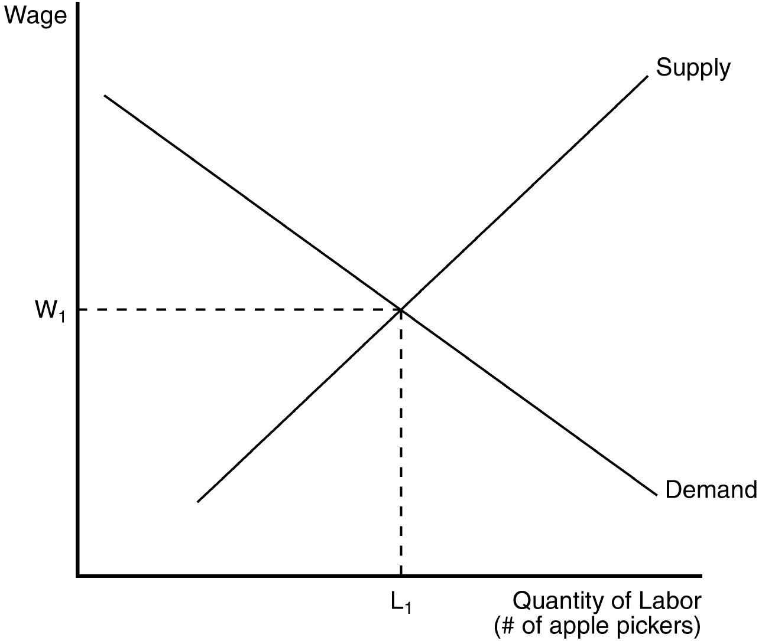

116. If the apple pickers start working fewer hours (by taking more vacation time), the equilibrium wage will
a. fall below w1 due to a shift in demand.
b. fall below w1 due to a shift in supply.
c. rise above w1 due to a shift in demand.
d. rise above w1 due to a shift in supply.
ANSWER: d. rise above w1 due to a shift in supply.
TYPE: M DIFFICULTY: 2 SECTION: 18.3
117. If the marginal product of labor falls and the price of apples remains unchanged,
(i) the value of the marginal product of labor will fall.
(ii) the quantity of labor demanded will increase above L1.
(iii) the labor supply curve will remain unchanged.
a. (i) and (ii)
b. (ii) and (iii)
c. (i) and (iii)
d. All of the above are correct.
ANSWER: c. (i) and (iii)
TYPE: M DIFFICULTY: 2 SECTION: 18.3
118. If the price of apples increases, the
a. demand for apple pickers will shift to the left.
b. demand for apple pickers will shift to the right.
c. supply of apple pickers will shift to the left.
d. supply of apple pickers will shift to the right.
ANSWER: b. demand for apple pickers will shift to the right.
TYPE: M DIFFICULTY: 2 SECTION: 18.3
119. If the price of apples increases, the wage will
a. increase and more apple pickers will be hired.
b. decrease and more apple pickers will be hired.
c. increase and fewer apple pickers will be hired.
d. decrease and fewer apple pickers will be hired.
ANSWER: a. increase and more apple pickers will be hired.
TYPE: M DIFFICULTY: 2 SECTION: 18.3
120. What happens to the profit earned by apple producers and to the wage earned by apple pickers when the price of apples rises?
a. Profit will rise and the wage will fall.
b. Profit will fall and the wage will rise.
c. Both profit and the wage will rise.
d. Both profit and the wage will fall.
ANSWER: c. Both profit and the wage will rise.
TYPE: M DIFFICULTY: 2 SECTION: 18.3
121. What happens to the profit earned by apple producers and the wage earned by apple pickers when the price of apples falls?
a. Both profit and the wage will fall.
b. Both profit and the wage will rise.
c. Profit will rise and the wage will fall.
d. Profit will fall and the wage will rise.
ANSWER: a. Both profit and the wage will fall.
TYPE: M DIFFICULTY: 2 SECTION: 18.3

Refer to the diagram below to answer Questions 122 through 126.

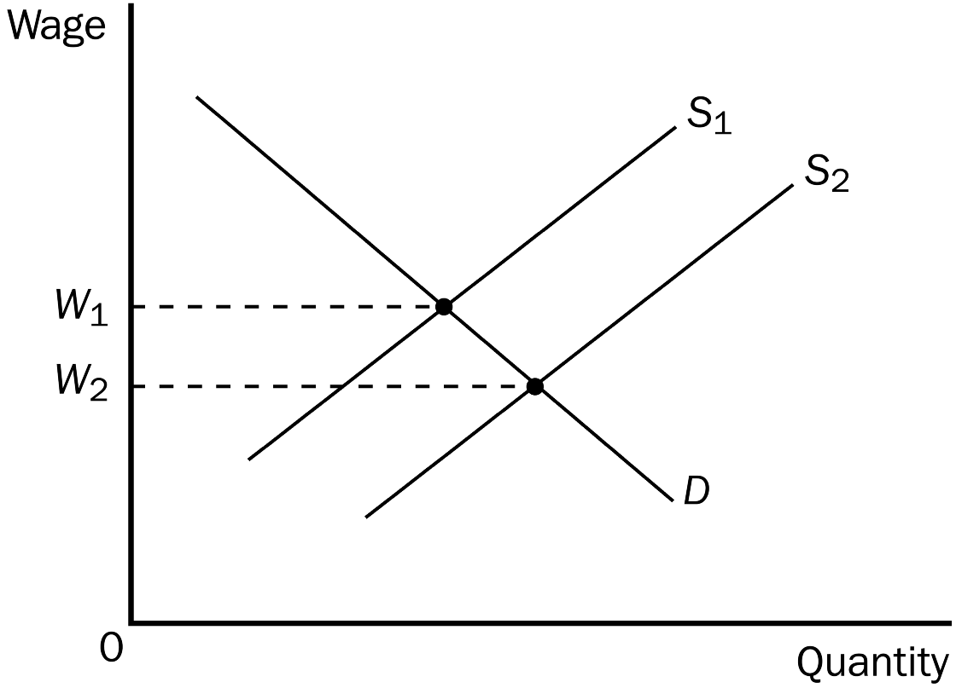

122. When the relevant labor supply curve is S1 and the labor market is in equilibrium,
a. the wage is W1.
b. the opportunity cost of leisure to workers is W1.
c. the value of the marginal product of labor to firms is W1.
d. All of the above are correct.
ANSWER: d. All of the above are correct.
TYPE: M DIFFICULTY: 2 SECTION: 18.3
123. The shift of the labor supply curve from S1 to S2 could possibly be explained by
a. technological progress.
b. a change in the price of firms’ output.
c. a change in workers’ attitudes toward the work-leisure tradeoff.
d. All of the above are correct.
ANSWER: c. a change in workers’ attitudes toward the work-leisure tradeoff.
TYPE: M DIFFICULTY: 2 SECTION: 18.3
124. The shift of the labor supply curve from S1 to S2 could possibly be explained by
a. a change in workers’ attitudes toward the work-leisure tradeoff.
b. decreases in wages in other labor markets.
c. immigration of workers into the region or country.
d. All of the above are correct.
ANSWER: d. All of the above are correct.
TYPE: M DIFFICULTY: 2 SECTION: 18.3
125. Assume W1 = $20 and W2 = $18 and the market is always in equilibrium. Then the shift of the labor supply curve from S1 to S2
a. increases the value of the marginal product of labor by $2.
b. decreases the value of the marginal product of labor by $2.
c. decreases the value of the marginal product of labor by more than $2.
d. does not change the value of the marginal product of labor.
ANSWER: b. decreases the value of the marginal product of labor by $2.
TYPE: M DIFFICULTY: 2 SECTION: 18.3
126. If the relevant labor supply curve is S2 and the current wage is W1,
a. there is a surplus of labor.
b. the quantity of labor demanded exceeds the quantity of labor supplied.
c. an increase in the minimum wage could be employed to restore equilibrium in the market.
d. All of the above are correct.
ANSWER: a. there is a surplus of labor.
TYPE: M DIFFICULTY: 2 SECTION: 18.3

Refer to the diagram below to answer Questions 127 through 131.

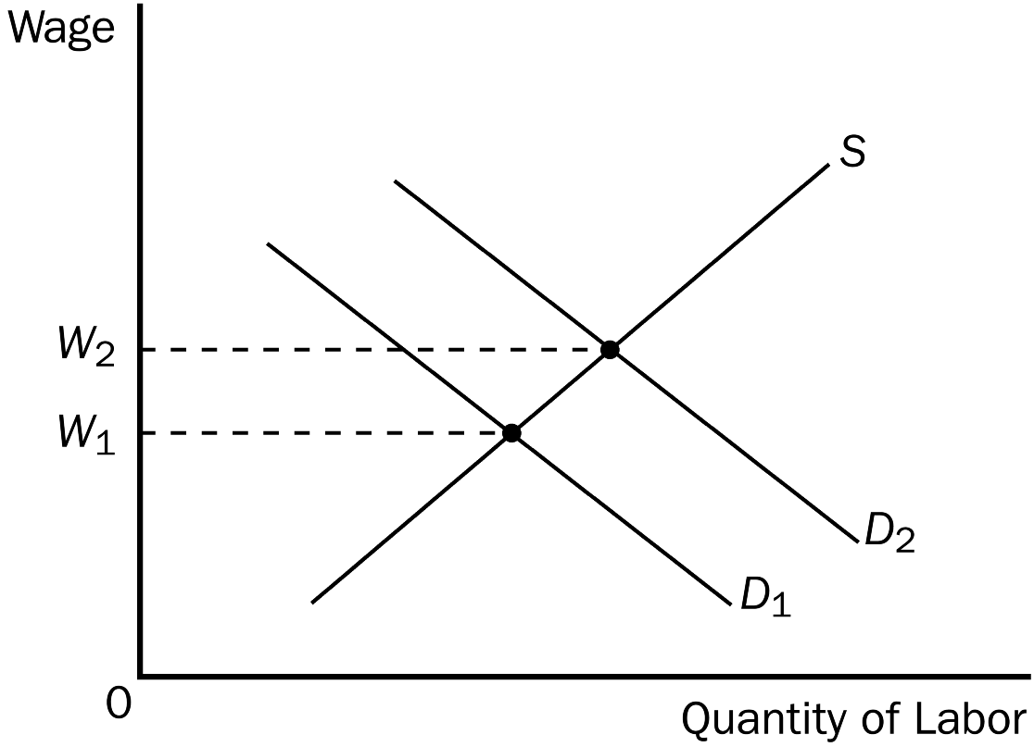

127. When the relevant labor demand curve is D1 and the labor market is in equilibrium,
a. the value of the marginal product of labor to firms is less than W1.
b. the opportunity cost of leisure to workers is greater than W1.
c. the wage is W1.
d. All of the above are correct.
ANSWER: c. the wage is W1.
TYPE: M DIFFICULTY: 2 SECTION: 18.3
128. The shift of the labor demand curve from D1 to D2 could possibly be explained by
a. technological progress.
b. an increase in the price of firms’ output.
c. an increase in the supply of a relevant factor of production other than labor.
d. All of the above are correct.
ANSWER: d. All of the above are correct.
TYPE: M DIFFICULTY: 3 SECTION: 18.3
129. The shift of the labor demand curve from D1 to D2 could possibly be explained by
a. a change in workers’ attitudes toward the work-leisure tradeoff.
b. decreases in wages in other labor markets.
c. an increase in the price of firms’ output.
d. All of the above are correct.
ANSWER: c. an increase in the price of firms’ output.
TYPE: M DIFFICULTY: 2 SECTION: 18.3
130. Assume W1 = $20 and W2 = $22 and the market is always in equilibrium. Then the shift of the labor demand curve from D1 to D2
a. increases the value of the marginal product of labor by $2.
b. increases the value of the marginal product of labor by less than $2.
c. decreases the value of the marginal product of labor by more than $2.
d. does not change the value of the marginal product of labor.
ANSWER: a. increases the value of the marginal product of labor by $2.
TYPE: M DIFFICULTY: 2 SECTION: 18.3
131. If the relevant labor demand curve is D2 and the current wage is W1,
a. there is a surplus of labor.
b. there is a shortage of labor.
c. the quantity of labor supplied exceeds the quantity of labor demanded.
d. workers are failing to take into account the work-leisure tradeoff in deciding what quantity of labor to supply at alternative wages.
ANSWER: b. there is a shortage of labor.
TYPE: M DIFFICULTY: 2 SECTION: 18.3
132. An increase in the value of the marginal product of labor has the effect of increasing the
a. demand for labor.
b. wage.
c. quantity of labor employed.
d. All of the above are correct.
ANSWER: d. All of the above are correct.
TYPE: M DIFFICULTY: 1 SECTION: 18.3
133. An increase in the supply of labor has the effect of decreasing the
a. wage.
b. marginal product of labor.
c. value of the marginal product of labor.
d. All of the above are correct.
ANSWER: d. All of the above are correct.
TYPE: M DIFFICULTY: 2 SECTION: 18.3
134. Suppose medical research provides evidence that eating bananas provides far greater health benefits than was previously thought. The resulting increase in the demand for bananas
a. increases the marginal product of banana pickers for any given number of banana pickers.
b. increases the value of the marginal product of banana pickers for any given number of banana pickers.
c. increases the supply of banana pickers.
d. All of the above are correct.
ANSWER: b. increases the value of the marginal product of banana pickers for any given number of banana pickers.
TYPE: M DIFFICULTY: 3 SECTION: 18.3
135. Both theory and history point to a close relationship between increases in
a. labor demand and increases in labor supply.
b. labor demand and decreases in real wages.
c. the productivity of labor and increases in real wages.
d. interest rates and decreases in real wages.
ANSWER: c. the productivity of labor and increases in real wages.
TYPE: M DIFFICULTY: 2 SECTION: 18.3
136. A market in which there is only one buyer is called a(n)
a. monopsony.
b. monopoly.
c. unipoly.
d. oligopsony.
ANSWER: a. monopsony.
TYPE: M DIFFICULTY: 1 SECTION: 18.3
137. Which of the following statements is correct?
a. The term “monopoly“ refers to either a market with one buyer or to a market with one seller.
b. The term “monopoly“ refers to a market with one buyer, while the term “monopsony“ refers to a market with one seller.
c. The term “monopsony“ refers to a market with one buyer, while the term “monopoly“ refers to a market with one seller.
d. The term “monopsony“ refers to either a market with one buyer or to a market with one seller.
ANSWER: c. The term “monopsony“ refers to a market with one buyer, while the term “monopoly“ refers to a market with one seller.
TYPE: M DIFFICULTY: 1 SECTION: 18.3
138. When a labor market is a monopsony, the monopsony firm
a. hires more workers than would a competitive firm.
b. hires fewer workers than is socially-optimal.
c. pays a higher wage than would a competitive firm.
d. is nevertheless regarded as a competitive firm in both the input and output markets.
ANSWER: b. hires fewer workers than is socially-optimal.
TYPE: M DIFFICULTY: 2 SECTION: 18.3
139. When an economist refers to a firm's capital, she/he is likely to be using the term to describe the
a. markets for final goods and services.
b. stock of equipment and buildings used in production.
c. amount of bank financing used by the firm.
d. amount of financing provided by the equity markets.
ANSWER: b. stock of equipment and buildings used in production.
TYPE: M DIFFICULTY: 1 SECTION: 18.4
140. The accumulation of machinery and buildings used in the production of new goods and services is referred to as
a. production factors.
b. output factors.
c. capital.
d. equity.
ANSWER: c. capital.
TYPE: M DIFFICULTY: 1 SECTION: 18.4
141. If one were to consider a university as a business, the computers in the computer labs would be regarded by economists as
a. technology flows.
b. mechanization flows.
c. part of the university’s stock of capital.
d. a flow of services from the university’s stock of capital.
ANSWER: c. part of the university’s stock of capital.
TYPE: M DIFFICULTY: 2 SECTION: 18.4
142. The purchase price of capital is
a. the value of the capital to the firm.
b. always less than the rental price.
c. the price received from the flow of some capital services.
d. the price a person pays to own that factor of production indefinitely.
ANSWER: d. the price a person pays to own that factor of production indefinitely.
TYPE: M DIFFICULTY: 2 SECTION: 18.4
143. The rental price of capital is
a. determined outside the realm of factor markets.
b. the price paid to use capital for a limited time period.
c. the price paid for ownership of the capital.
d. always more than the purchase price.
ANSWER: b. the price paid to use capital for a limited time period.
TYPE: M DIFFICULTY: 2 SECTION: 18.4
144. The rental price of land is
a. the price paid for ownership of the land.
b. the price paid for the flow of services from land over a specified time period.
c. always more than the purchase price.
d. All of the above are correct.
ANSWER: b. the price paid for the flow of services from land over a specified time period.
TYPE: M DIFFICULTY: 2 SECTION: 18.4
145. The rental price of capital is determined by
a. forces of supply and demand in capital markets.
b. the amount of equity that is generated in equity markets.
c. the amount of bond financing used by profit-maximizing firms.
d. the amount of dividends paid out to stockholders by profit-maximizing firms.
ANSWER: a. forces of supply and demand in capital markets.
TYPE: M DIFFICULTY: 2 SECTION: 18.4
146. Owners of land are compensated according to the
a. absolute level of production from the land.
b. number of laborers the land can support.
c. purchase price of the land stock.
d. value of the marginal product of land.
ANSWER: d. value of the marginal product of land.
TYPE: M DIFFICULTY: 2 SECTION: 18.4
147. The owners of capital resources are compensated according to the
a. purchase price of the capital stock.
b. marginal product of capital.
c. value of the marginal product of capital.
d. absolute level of production of final goods and services.
ANSWER: c. value of the marginal product of capital.
TYPE: M DIFFICULTY: 2 SECTION: 18.4
148. The marginal product of any factor of production depends on
a. the quantity of the factor used.
b. the price of the final good.
c. the demand for the final good.
d. All of the above are correct.
ANSWER: a. the quantity of the factor used.
TYPE: M DIFFICULTY: 2 SECTION: 18.4
149. Because of diminishing returns, a factor in abundant supply has
a. a high marginal product and a high rental price.
b. a high marginal product and a low rental price.
c. a low marginal product and a high rental price.
d. a low marginal product and a low rental price.
ANSWER: d. a low marginal product and a low rental price.
TYPE: M DIFFICULTY: 2 SECTION: 18.4
150. Because of diminishing returns, a factor in scarce supply has
a. a low marginal product and a low rental price.
b. a low marginal product and a high rental price.
c. a high marginal product and a low rental price.
d. a high marginal product and a high rental price.
ANSWER: d. a high marginal product and a high rental price.
TYPE: M DIFFICULTY: 2 SECTION: 18.4
151. If the government designates certain areas within a community to be “wetlands,“ and therefore illegal to build upon, what happens to land not classified as "wetlands" within the community?
(i) The price of non-wetland land will rise.
(ii) The marginal product of non-wetland land will fall.
(iii) The marginal product of non-wetland land will rise.
a. (i) and (ii)
b. (ii) and (iii)
c. (i) and (iii)
d. (ii) only
ANSWER: c. (i) and (iii)
TYPE: M DIFFICULTY: 2 SECTION: 18.4
152. As a result of a severe flooding, a farmer loses one half of his productive farmland. He should expect to see the marginal productivity of his remaining land
a. increase.
b. remain unchanged.
c. decrease, but remain positive.
d. decrease and become negative.
ANSWER: a. increase.
TYPE: M DIFFICULTY: 2 SECTION: 18.4
153. As a result of a severe flooding, a farmer loses one half of his productive farmland. If the property of diminishing returns applies to all factors of production, he should expect to see
a. an increase in the marginal productivity of his remaining land and an increase in the marginal productivity of his labor.
b. an increase in the marginal productivity of his remaining land and a decrease in the marginal productivity of his labor.
c. a decrease in the marginal productivity of his remaining land and an increase in the marginal productivity of his labor.
d. a decrease in the marginal productivity of his remaining land and a decrease in the marginal productivity of his labor.
ANSWER: b. an increase in the marginal productivity of his remaining land and a decrease in the marginal productivity of his labor.
TYPE: M DIFFICULTY: 3 SECTION: 18.4
154. A change in supply of one factor of production
a. will not change either the marginal productivities or the prices of other factors.
b. will not change the prices of other factors, but it may change their marginal productivities.
c. will not change the marginal productivities of other factors, but it may change their prices.
d. changes the marginal productivities and the prices of other factors.
ANSWER: d. changes the marginal productivities and the prices of other factors.
TYPE: M DIFFICULTY: 2 SECTION: 18.4
155. The equilibrium rental income paid to landowners at any point in time equals the
a. purchase price of land.
b. value of the marginal product of land.
c. marginal product of land.
d. wage paid to laborers.
ANSWER: b. value of the marginal product of land.
TYPE: M DIFFICULTY: 2 SECTION: 18.4
156. The equilibrium rental income paid to the owners of capital at any point in time equals the
a. marginal product of capital.
b. value of the marginal product of capital.
c. percentage of profits paid out to stockholders in the form of dividends.
d. equilibrium purchase price of capital.
ANSWER: b. the value of the marginal product of capital.
TYPE: M DIFFICULTY: 2 SECTION: 18.4
157. Who receives income from capital in the United States?
a. bank depositors
b. bondholders
c. stockholders
d. All of the above are correct.
ANSWER: d. All of the above are correct.
TYPE: M DIFFICULTY: 2 SECTION: 18.4
158. Which of the following qualify as part of our economy’s capital income?
a. wages paid to workers
b. interest paid to the owners of corporate bonds
c. salaries paid to chief executive officers of corporations
d. All of the above are correct.
ANSWER: b. interest paid to the owners of corporate bonds
TYPE: M DIFFICULTY: 2 SECTION: 18.4
159. If you purchase a share in the ownership of a firm you are said to be a
a. profiteer.
b. renter.
c. bondholder.
d. stockholder.
ANSWER: d. stockholder.
TYPE: M DIFFICULTY: 1 SECTION: 18.4
160. In economics, the term capital is used to refer to
a. money.
b. stocks and bonds.
c. equipment and structures used in production.
d. All of the above are correct.
ANSWER: c. equipment and structures used in production.
TYPE: M DIFFICULTY: 1 SECTION: 18.4
161. With regard to capital, it is important to distinguish between
a. the supply price of capital and the demand price of capital.
b. the rental price of capital and the purchase price of capital.
c. firms and the demanders of capital.
d. the suppliers of capital and the owners of capital.
ANSWER: b. the rental price of capital and the purchase price of capital.
TYPE: M DIFFICULTY: 2 SECTION: 18.4
162. The distinction between purchase price and rental price applies to which factor(s) of production?
a. land only
b. capital only
c. land and capital only
d. land, capital, and labor
ANSWER: c. land and capital only
TYPE: M DIFFICULTY: 2 SECTION: 18.4
163. Which term below refers to “the accumulation of goods produced in the past that are being used in the present to produce new goods and services?”
a. inventories
b. products
c. factors of production
d. capital
ANSWER: d. capital
TYPE: M DIFFICULTY: 1 SECTION: 18.4
164. The determination of the demand for land is essentially the same as the determination of the
a. demands for goods and services.
b. demands for labor and capital.
c. supplies of labor and capital.
d. supplies of all factors of production.
ANSWER: b. demands for labor and capital.
TYPE: M DIFFICULTY: 2 SECTION: 18.4
165. “The firm hires the factor up to the point where the value of the factor’s marginal product is equal to the factor’s price.“ This statement applies to which factor of production?
a. labor
b. land
c. capital
d. All of the above are correct.
ANSWER: d. All of the above are correct.
TYPE: M DIFFICULTY: 2 SECTION: 18.4
166. The current value of the marginal product of land influences the
a. demand for land.
b. equilibrium rental price of land.
c. equilibrium purchase price of land.
d all of the above.
ANSWER: d. all of the above.
TYPE: M DIFFICULTY: 2 SECTION: 18.4
167. Capital is paid according to the value of its marginal product
a. only if earnings from capital are paid to households in the form of dividends.
b. only if earnings from capital are kept within firms as retained earnings.
c. regardless of whether earnings from capital are paid to households in the form of dividends or whether those earnings are kept within firms as retained earnings.
d. None of the above are correct; capital is a factor of production for which earnings are unrelated to the value of marginal product.
ANSWER: c. regardless of whether earnings from capital are paid to households in the form of dividends or whether those earnings are kept within firms as retained earnings.
TYPE: M DIFFICULTY: 3 SECTION: 18.4
168. The Black Death in fourteenth-century Europe resulted in
a. a lower marginal product of land.
b. a lower marginal product of labor of surviving workers.
c. economic hardship for surviving peasants.
d. economic prosperity for surviving landowners.
ANSWER: a. a lower marginal product of land.
TYPE: M DIFFICULTY: 3 SECTION: 18.4
TRUE/FALSE
1. In 1999, the total income of all U.S. residents was about $8 billion.
ANSWER: F TYPE: TF DIFFICULTY: 1 SECTION: 18.1
2. The demand for computer programmers is inextricably tied to the supply of computer software.
ANSWER: T TYPE: TF DIFFICULTY: 1 SECTION: 18.1
3. If Firm X is a competitive firm in the market for labor, it has little influence over the wage it pays its employees.
ANSWER: T TYPE: TF DIFFICULTY: 1 SECTION: 18.1
4. The idea that rational employers think at the margin is central to understanding how many units of labor they choose to employ.
ANSWER: T TYPE: TF DIFFICULTY: 1 SECTION: 18.1
5. For competitive firms, the curve that represents the value of marginal product of labor is the same as the demand-for-labor curve.
ANSWER: T TYPE: TF DIFFICULTY: 2 SECTION: 18.1
6. The value of the marginal product of labor can be calculated as the price of the final good minus the marginal product of labor.
ANSWER: F TYPE: TF DIFFICULTY: 2 SECTION: 18.1
7. A competitive, profit-maximizing firm hires workers up to the point at which the wage equals the price of the final good.
ANSWER: F TYPE: TF DIFFICULTY: 2 SECTION: 18.1
8. Technological advances can cause the labor demand curve to shift.
ANSWER: T TYPE: TF DIFFICULTY: 2 SECTION: 18.1
9. In the United States, technological advances help explain persistently rising employment in the face of rising wages.
ANSWER: T TYPE: TF DIFFICULTY: 2 SECTION: 18.1
10. The quantity available of one factor of production can affect the marginal product of other factors.
ANSWER: T TYPE: TF DIFFICULTY: 2 SECTION: 18.1
11. The opportunity cost of leisure is impossible to measure, since we can’t measure leisure time in dollars.
ANSWER: F TYPE: TF DIFFICULTY: 2 SECTION: 18.2
12. The labor supply curve reflects how workers’ decisions about the labor-leisure tradeoff respond to changes in the opportunity cost of leisure.
ANSWER: T TYPE: TF DIFFICULTY: 2 SECTION: 18.2
13. Labor supply curves are always upward sloping.
ANSWER: F TYPE: TF DIFFICULTY: 2 SECTION: 18.2
14. The supply of labor in any one market depends on the opportunities available in other markets.
ANSWER: T TYPE: TF DIFFICULTY: 2 SECTION: 18.2
15. Movements of workers from country to country can cause shifts in the labor supply curves for both countries.
ANSWER: T TYPE: TF DIFFICULTY: 2 SECTION: 18.2
16. In a competitive market for labor, the equilibrium wage always equals the value of the marginal product.
ANSWER: T TYPE: TF DIFFICULTY: 2 SECTION: 18.3
17. As the number of concrete workers in the United States falls, the wage paid to the remaining concrete workers will necessarily fall as well.
ANSWER: F TYPE: TF DIFFICULTY: 2 SECTION: 18.3
18. Oil field workers’ wages are directly tied to the world price of oil.
ANSWER: T TYPE: TF DIFFICULTY: 1 SECTION: 18.3
19. Changes in supply and demand in the labor market will cause changes in wages.
ANSWER: T TYPE: TF DIFFICULTY: 1 SECTION: 18.3
20. In general, less productive workers are paid less than more productive workers.
ANSWER: T TYPE: TF DIFFICULTY: 1 SECTION: 18.3
21. Increases in productivity are not responsible for increased standards of living in the United States.
ANSWER: F TYPE: TF DIFFICULTY: 2 SECTION: 18.3
22. Average productivity can be measured as total output divided by total units of labor.
ANSWER: T TYPE: TF DIFFICULTY: 1 SECTION: 18.3
23. For a lawn mowing and yard maintenance business, the capital stock would include lawn mowers, rakes, shovels, and hoses.
ANSWER: T TYPE: TF DIFFICULTY: 1 SECTION: 18.4
24. The demand curve for each factor of production reflects the marginal productivity of that factor.
ANSWER: T TYPE: TF DIFFICULTY: 2 SECTION: 18.4
25. Capital income does not include income paid to households for the use of their capital.
ANSWER: F TYPE: TF DIFFICULTY: 2 SECTION: 18.4
26. Firms pay out a portion of their earnings in the form of interest and dividends, and those payments are a portion of the economy’s capital income.
ANSWER: T TYPE: TF DIFFICULTY: 2 SECTION: 18.4
27. When a firm decides to retain its earnings instead of paying dividends, the stockholders necessarily suffer.
ANSWER: F TYPE: TF DIFFICULTY: 2 SECTION: 18.4
28. Capital owners are compensated according to the value of the marginal product of that capital.
ANSWER: T TYPE: TF DIFFICULTY: 2 SECTION: 18.4
29. A change in the supply of any one factor alters the earnings of all the other factors.
ANSWER: T TYPE: TF DIFFICULTY: 2 SECTION: 18.4
30. As the rental price of capital increases, less capital is used in production.
ANSWER: T TYPE: TF DIFFICULTY: 1 SECTION: 18.4
31. As the rental price of capital decreases, more capital is used in production and the marginal product of capital increases.
ANSWER: F TYPE: TF DIFFICULTY: 2 SECTION: 18.4
32. If a disease, like the Black Death, were to significantly decrease the population of a country, we would predict a decrease in the marginal product of land.
ANSWER: T TYPE: TF DIFFICULTY: 2 SECTION: 18.4
SHORT ANSWER
1. Describe the difference between a diminishing marginal product of labor and a negative marginal product of labor. Why would a profit-maximizing firm always choose to operate where marginal product of labor is decreasing (but not negative)?
ANSWER: Diminishing marginal product of labor means that the last worker hired contributes less to the total output of the firm than the worker that was hired just previous to her. Negative marginal product of labor suggests that the last person hired actually causes total output of the firm to decline. If wages are constant and marginal product is decreasing, it forces the firm to evaluate the benefit of hiring (added revenue) versus the added cost of hiring (wage). In competitive markets, the cost and benefit converge only when marginal product declines. If marginal product of labor is negative, hiring an additional worker would actually decrease revenue.
TYPE: S DIFFICULTY: 2 SECTION: 18.1
2. Explain how a firm values the contribution of workers to its profitability. Would a profit-maximizing competitive firm ever stop increasing employment as long as marginal product is rising? Explain your answer.
ANSWER: A firm values the contribution of a worker by evaluating the worker’s individual contribution to firm revenue. This is done by multiplying their marginal product by the output price received for their production. A profit-maximizing firm would never choose to operate where marginal product is rising because hiring an additional worker would increase the "value" a worker contributes to the firm and cost would remain constant. As such, value and cost diverge as long a marginal product is increasing, and it is always more profitable to continue to hire more workers.
TYPE: S DIFFICULTY: 2 SECTION: 18.1
3. In the 1980s, the dangerous Ebola virus entered the United States through contaminated monkeys that were imported for use in medical experiments. Suppose this virus had not been contained, and had spread to the general population. Describe the resulting effect on labor productivity. (Assume that the virus is lethal in half of the people who are exposed to the virus.)
ANSWER: There are two possible direct effects: One effect would be that people would be absent from work if they caught the virus (but did not die) and so marginal productivity would be higher for the remaining workers. The other effect is that people who caught the virus would die and thus the labor supply would decrease and the remaining workers would have a higher marginal product of labor. While labor productivity of remaining workers increases, total output would still fall.
TYPE: S DIFFICULTY: 2 SECTION: 18.3
4. Using the theory of wage determination, explain why wages in developing countries are typically quite low.
ANSWER: Wages are determined by the value of workers to firms. In many developing countries, the level of capital is quite small, and so worker productivity is quite low. As such, workers are not able to contribute as much value to a firm as their counterparts in countries that have more capital to complement their labor efforts. Since marginal productivity is low, wages are low.
TYPE: S DIFFICULTY: 2 SECTION: 18.3
5. A recent flood in the Midwest has destroyed much of the farmland that lies in fertile regions near the rivers. Describe the effect of the flood on the marginal productivity of land, labor, and capital. How would the flood affect the price of inputs? Provide some examples.
ANSWER: The flood would increase the marginal product of land and lower the marginal product of labor and capital. As such, the price of unflooded land should rise and the price of labor and capital should fall.
TYPE: S DIFFICULTY: 2 SECTION: 18.3
6. Describe the process by which the market for capital and the market for land reach equilibrium. As part of your description, elaborate on the role of the stock of the resource versus the flow of services from the resource.
ANSWER: Equilibrium in the markets for land and capital are governed by the value of marginal product for these factors relative to their supply. One difference between these markets and the market for labor is the distinction between rental value (flow) and purchase price (stock). This difference is reconciled by noting that in efficient markets, the purchase price should reflect the value of the stream of services provided by the land or capital (or the sum of rental values appropriately discounted).
TYPE: S DIFFICULTY: 3 SECTION: 18.4
7. Describe the difference between the purchase price of capital and the rental price of capital. If you know the value of marginal product from the flow of capital services, how would you determine the market price for the capital stock?
ANSWER: The purchase price of capital is a reflection of the flow of value in using that capital to produce goods and services over its life span. The rental price of capital is the period specific contribution of capital to production of goods and services. The discounted present value of rental prices over the life of the capital equipment should be equal to its purchase price.
TYPE: S DIFFICULTY: 3 SECTION: 18.4

